Lab 6: Punny Magnetic Force Title
Abdon M., Lourdes Z.
Date: October 28, 2025
Part I
Method
For Part 1 of the lab we will be using fitting techniques that we have learned to form and test a model that will describe the force between two magnets. We will be collecting force-disctance pairs to test our first prediction of the power law exponent, ɑ. Given the model$lnF=αlnr+lnK=αlnr+B$, we can see that alpha is going to be the slope on our graph. With this, we are predicting the power law exponent to be about -2.0. We are also predicting that the force between the repelling magnets will decrease as distance increases. To test our predictions we will be utilizing the following equipment: ring magnets, weights, digital caliper, and a ring stand. The model we created started with sliding two magnets on the ring stand, placing them so they are repelling each other. We then began to add weights onto the ring stand, and measured the distance between the magnets with a digital caliper (the caliper will have an uncertainty of +/- 0.2). We continued to add weights starting with 10g and increasing in increments of 10g until we reached 100g, allowing us to add measurable force. By using this model we were able to make a graph using linear fitting to show the relationship between $lnF$ and $lnR$, and ultimately observe if our prediction was correct or not. A chi squared test will also be performed when analyzing our data.
- Equipment/Experimental Systems
  - Ring magnets: used to test force between repelling magnets (2 magnets)
  - Weights: used to measure the relationship between force and distance
  - Digital caliper: used for precise measurements of distance between magnets
  - Ring stand: used to slide magnets and weights onto
- Variables
  - Independent variables: force
  - Dependent variables: distance between magnets
  - Controlled variables: magnet type, orientation of magnets and weights, calibration of caliper
- Statistical and Analytical tools
  - Non Linear Fitting
  - Chi Squared
    - $χ^{2}=\frac{1}{N-1}Σ\frac{(B-B)^{2}}{δB^{2}}$
Data
Mass (g) (+/- 0.5) | Distance (mm) (+/- 0.2) | F | ln F | ln R
10 | 18.7 | 98.1 | 4.585987367 | 2.928523524
20 | 16.6 | 196.2 | 5.279134547 | 2.809402695
30 | 13 | 294.3 | 5.684599655 | 2.564949357
40 | 12.2 | 392.4 | 5.972281728 | 2.501435952
50 | 10.1 | 490.5 | 6.195425279 | 2.312535424
60 | 9.5 | 588.6 | 6.377746836 | 2.251291799
70 | 9.1 | 686.7 | 6.531897516 | 2.208274414
80 | 8.2 | 784.8 | 6.665428908 | 2.104134154
90 | 7.7 | 882.9 | 6.783211944 | 2.041220329
100 | 7.3 | 981 | 6.88857246 | 1.987874348
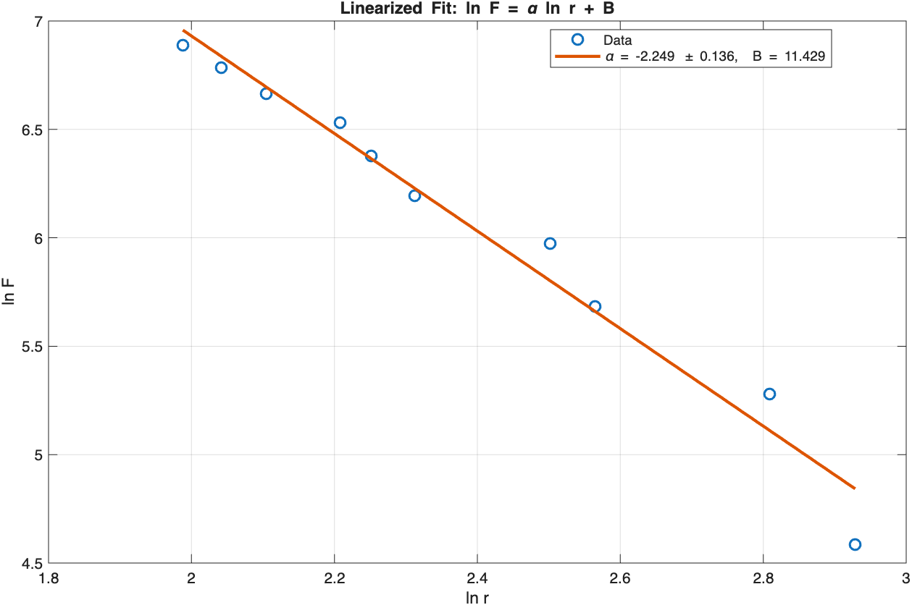
Data Output:
>> PartI_model

alpha = -2.2491 ± 0.1365 (SE)
B = 11.4290
R^2 = 0.9714
RSS = 0.138351
s^2 = 0.017294
dof = 8
chi^2 = 8.000000
chi^2_red = 1.000000
Conclusion
In this part of the experiment, we conclude that our data aligns with the power law and what the exponent should equal. The $α$ that we got equaled -2.249 we are able to say that our model was able to correctly identify the exponent. From our results we see a negative linear relationship between $lnF$ and $lnR$. Since we made a prediction of ɑ being -0.2 the results are indistinguishable from our prediction made. When looking at the graph we do see some deviations from the best fit line that can be due to the prediction not holding equal at all distances. This is most likely caused from the force between the magnets being weaker at larger distances, since we do see tighter and more precise data as the distance decreases. There are possible ambiguities from the digital caliper when measuring the distances. Another is the magnets staying aligned and keeping them stable when measuring. We can also see from our reduced chi squared that we have a good fit. So, we are able to determine the model as a good representation of the power law and the inverse square behavior since it is equal to 1.0, even with uncertainties. For future iterations of the experiment we could:
- Use a calibrated force sensor to get a more accurate representation of the force between the magnets
- Take multiple measurements at each increment of weight to decrease uncertainties
- Improving the alignment of the magnets and decreasing any friction that could affect the results

Part II
Method
For the second part of the lab, we will be testing a different aspect of the magnet model we previously used. To do so we are increasing the number of magnets and seeing how force changes between them (a second magnet was added to both previous magnets to equal 4 magnets used in total). We will be utilizing the same experimental tools and analysis as we did in Part 1, along with using the same model. By adding a second magnet to each repelling side, we predicted that the ɑ will increase. We are also predicting that the force is going to increase as well with the addition of the magnets. We will be starting by adding a magnet with mass 10g and increasing in 10g increments until we reach 100g. By using the digital caliper we get as precise measurements as possible (the caliper will have an uncertainty of +/- 0.2). We will also be using the linear fitting model to make a graph with the recorded data of $lnF$ and $lnR$. A chi squared test will be performed when analyzing our data.
- Equipment/Experimental Systems
  - Ring magnets: used to test force between repelling magnets (4 magnets)
  - Weights: used to measure the relationship between force and distance
  - Digital caliper: used for precise measurements of distance between magnets
  - Ring stand: used to slide magnets and weights onto
- Variables
  - Independent variables: force
  - Dependent variables: distance between magnets
  - Controlled variables: magnet type, orientation of magnets and weights, calibration of caliper
- Statistical and Analytical tools
  - Non Linear Fitting
  - Chi Squared
    - $χ^{2}=\frac{1}{N-1}Σ\frac{(B-B)^{2}}{δB^{2}}$

Data
Mass (g) (+/- 0.5) | Distance (mm) (+/- 0.2) | f | ln F | ln R
10 | 25.3 | 98.1 | 4.585987367 | 3.230804396
20 | 22.5 | 196.2 | 5.279134547 | 3.113515309
30 | 20.5 | 294.3 | 5.684599655 | 3.020424886
40 | 18.8 | 392.4 | 5.972281728 | 2.93385687
50 | 17.5 | 490.5 | 6.195425279 | 2.862200881
60 | 15.5 | 588.6 | 6.377746836 | 2.740840024
70 | 14.7 | 686.7 | 6.531897516 | 2.687847494
80 | 14 | 784.8 | 6.665428908 | 2.63905733
90 | 13.2 | 882.9 | 6.783211944 | 2.58021683
100 | 12 | 981 | 6.88857246 | 2.48490665
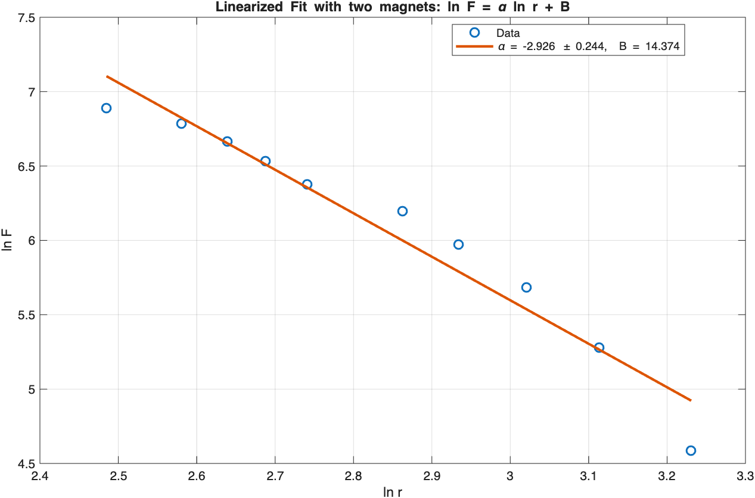
Data Output:
>> PartII_model

alpha = -2.9256 ± 0.2441 (SE)
B = 14.3740
R^2 = 0.9472
RSS = 0.255113
s^2 = 0.031889
dof = 8
chi^2 = 8.000000
chi^2_red = 1.000000
Conclusion
In Part 2 we found the power law exponent $α$ to equal -2.9256, which differs from our Part 1 $α$ = -2.2491. By getting a more negative $α$, we are observing the force decreasing more with distance as the multiple magnets are interacting with each other. The modification in the set up resulted in an exponent that closely agrees with our prediction as well. By getting a reduced chi square of 1.0 we are also able to say that our data fit well with the model, showing our exponent consistent with the power law theory. Uncertainties were not significant enough to consider. Any limitations in Part 2 are most likely the same as from Part 1. Those being from the digital caliper when measuring the distances and difficulty with the magnets staying aligned and keeping them stable when measuring. For future iterations of this experiment we could:
- Vary the magnet orientation/type and see what outcomes would differ from the change
- Implement magnetic shielding to stop any disruptions from nearby magnetic forces
- Extend the range of distances done with weights that would allow for increments of 5g or less

